# The Simple Game (Notes)

## Setting Up – N-tier and Modified MVVM Using a Static Data Service

1. **App.xaml**

* calls **Application_Startup** in **App.xaml.cs**.  
  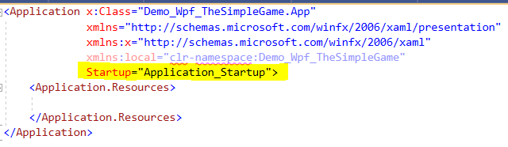

1. **App.xaml.cs**

* Instantiates a ***GameViewModel*** object.
* Instantiates a ***GameView*** object with the view model as an argument.
* Sets the views **DataContext** property to the view model.
* Opens and sows the window.  
  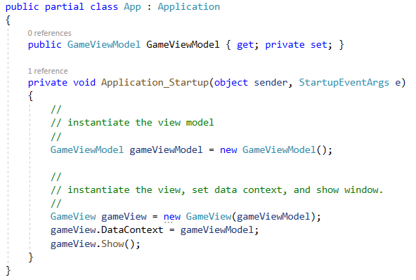

1. **GameView.cs**

* Assigns the view model parameter to the **_gameViewModel** field.  
  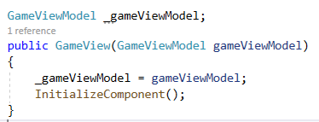

1. **IDataService.cs**

* Describes the interface methods

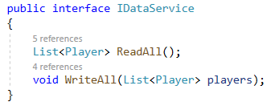

1. **DataService.cs**

* Returns an explicit list of players
* Note the stubbed **WriteAll** method to satisfy the ***IDataService*** interface.

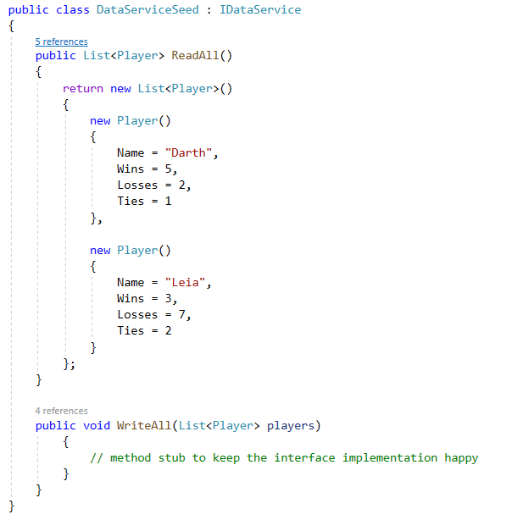

1. **GameBusiness.cs**

* Declares a data service using the ***IDataService*** interface.
* Instantiates the data service.
* Reads all players from data into a list, **_allPlayers**.
* Assigns the **_playerOne** and **_playerTwo** fields.  
  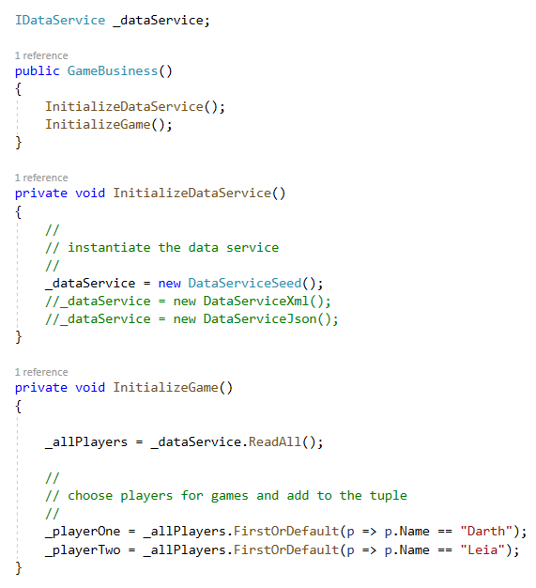

1. **GameViewModel.cs**

* Instantiates a ***GameBusiness*** object.
* Gets the current players from the ***GameBusiness*** object and assigns them to the **_currentPlayers**, **_playerX**, and **_playerO** fields.
* Instantiates a ***GameBoard*** object and sets the initial game parameters.  
  